Transaction States in DBMS

Transaction in DBMS is a set of logically related operations executed as a single unit. These logic are followed to perform modification on data while maintaining integrity and consistency. Transactions are performed in a way that concurrent actions from different users don’t malfunction the database. Transfer of money from one account to another in a bank management system is the best example of Transaction.
States through which a transaction goes during its lifetime. These are the states which tell about the current state of the Transaction and also tell how we will further do the processing in the transactions. These states govern the rules which decide the fate of the transaction whether it will be committed or aborted. They also use a Transaction log.

Transaction States in DBMS
A Transaction log is a file maintained by the recovery management component to record all the activities of the transaction. After the commit is done transaction log file is removed.

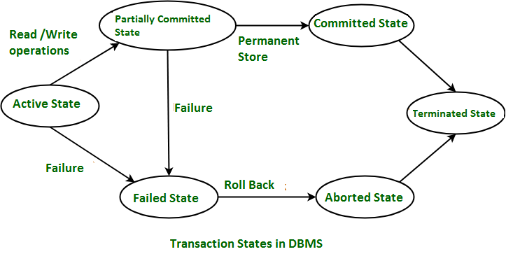

In DBMS, a transaction passes through various states such as active, partially committed, failed, and aborted. Understanding these transaction states is crucial for database management and ensuring the consistency of data.

These are different types of Transaction States :

1. Active State – When the instructions of the transaction are running then the transaction is in active state. If all the ‘read and write’ operations are performed without any error then it goes to the “partially committed state”; if any instruction fails, it goes to the “failed state”.
2. Partially Committed – After completion of all the read and write operation the changes are made in main memory or local buffer. If the changes are made permanent on the DataBase then the state will change to “committed state” and in case of failure it will go to the “failed state”.
3. Failed State – When any instruction of the transaction fails, it goes to the “failed state” or if failure occurs in making a permanent change of data on Database.
4. Aborted State – After having any type of failure the transaction goes from “failed state” to “aborted state” and since in previous states, the changes are only made to local buffer or main memory and hence these changes are deleted or rolled-back.
5.Committed State – It is the state when the changes are made permanent on the Data Base and the transaction is complete and therefore terminated in the “terminated state”.
6.Terminated State – If there isn’t any roll-back or the transaction comes from the “committed state”, then the system is consistent and ready for new transaction and the old transaction is terminated.

ACID Properties in DBMS (If asked for Long answer)
DBMS is the management of data that should remain integrated when any changes are done in it. It is because if the integrity of the data is affected, whole data will get disturbed and corrupted. Therefore, to maintain the integrity of the data, there are four properties described in the database management system, which are known as the ACID properties. The ACID properties are meant for the transaction that goes through a different group of tasks, and there we come to see the role of the ACID properties.
The expansion of the term ACID defines for:

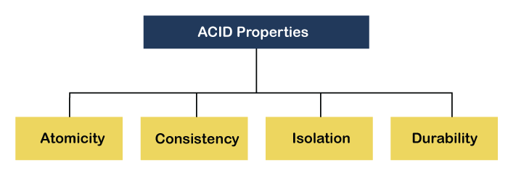

Atomicity
By this, we mean that either the entire transaction takes place at once or doesn’t happen at all. There is no midway i.e. transactions do not occur partially. Each transaction is considered as one unit and either runs to completion or is not executed at all. It involves the following two operations.
— Abort : If a transaction aborts, changes made to the database are not visible.
— Commit : If a transaction commits, changes made are visible.
Atomicity is also known as the ‘All or nothing rule’.

Consider the following transaction T consisting of T1 and T2 : Transfer of 100 from account X to account Y .
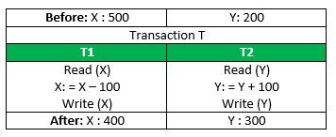
If the transaction fails after completion of T1 but before completion of T2 .( say, after write(X) but before write(Y) ), then the amount has been deducted from X but not added to Y . This results in an inconsistent database state. Therefore, the transaction must be executed in its entirety in order to ensure the correctness of the database state.

Consistency:
This means that integrity constraints must be maintained so that the database is consistent before and after the transaction. It refers to the correctness of a database. Referring to the example above,
The total amount before and after the transaction must be maintained.
Total before T occurs = 500 + 200 = 700 .
Total after T occurs = 400 + 300 = 700 .
Therefore, the database is consistent . Inconsistency occurs in case T1 completes but T2 fails. As a result, T is incomplete.

Isolation:
This property ensures that multiple transactions can occur concurrently without leading to the inconsistency of the database state. Transactions occur independently without interference. Changes occurring in a particular transaction will not be visible to any other transaction until that particular change in that transaction is written to memory or has been committed. This property ensures that the execution of transactions concurrently will result in a state that is equivalent to a state achieved these were executed serially in some order.
Let X = 500, Y = 500.
Consider two transactions T and T”.

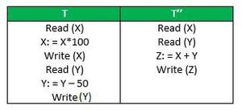
Suppose T has been executed till Read (Y) and then T’’ starts. As a result, interleaving of operations takes place due to which T’’ reads the correct value of X but the incorrect value of Y and sum computed by
T’’: (X+Y = 50, 000+500=50, 500)
is thus not consistent with the sum at end of the transaction:
T: (X+Y = 50, 000 + 450 = 50, 450) .
This results in database inconsistency, due to a loss of 50 units. Hence, transactions must take place in isolation and changes should be visible only after they have been made to the main memory.

Durability:
This property ensures that once the transaction has completed execution, the updates and modifications to the database are stored in and written to disk and they persist even if a system failure occurs. These updates now become permanent and are stored in non-volatile memory. The effects of the transaction, thus, are never lost.

ACID Properties ( If asked for Short answer)

ACID properties are the four key characteristics that define the reliability and consistency of a transaction in a Database Management System (DBMS). The acronym ACID stands for Atomicity, Consistency, Isolation, and Durability. Here is a brief description of each of these properties:
- Atomicity: Atomicity ensures that a transaction is treated as a single, indivisible unit of work. Either all the operations within the transaction are completed successfully, or none of them are. If any part of the transaction fails, the entire transaction is rolled back to its original state, ensuring data consistency and integrity.
- Consistency: Consistency ensures that a transaction takes the database from one consistent state to another consistent state. The database is in a consistent state both before and after the transaction is executed. Constraints, such as unique keys and foreign keys, must be maintained to ensure data consistency.
- Isolation: Isolation ensures that multiple transactions can execute concurrently without interfering with each other. Each transaction must be isolated from other transactions until it is completed. This isolation prevents dirty reads, non-repeatable reads, and phantom reads.
- Durability: Durability ensures that once a transaction is committed, its changes are permanent and will survive any subsequent system failures. The transaction’s changes are saved to the database permanently, and even if the system crashes, the changes remain intact and can be recovered.
Overall, ACID properties provide a framework for ensuring data consistency, integrity, and reliability in DBMS. They ensure that transactions are executed in a reliable and consistent manner, even in the presence of system failures, network issues, or other problems. These properties make DBMS a reliable and efficient tool for managing data in modern organizations.

Advantages of ACID Properties in DBMS
- Data Consistency: ACID properties ensure that the data remains consistent and accurate after any transaction execution.
- Data Integrity: ACID properties maintain the integrity of the data by ensuring that any changes to the database are permanent and cannot be lost.
- Concurrency Control: ACID properties help to manage multiple transactions occurring concurrently by preventing interference between them.
- Recovery: ACID properties ensure that in case of any failure or crash, the system can recover the data up to the point of failure or crash.

Serializability:
Serializability is a type of property of DBMS in which each transaction is executed independently and automatically, even though these transactions are executed concurrently. In other words, we can say that if there are several transactions executed concurrently, then the main work of the serializability function is to arrange these several transactions in a sequential manner.
Suppose there are two users Sona and Archita. Each executes two transactions. Let's transactions T1 and T2 are executed by Sona, and T3 and T4 are executed by Archita. Suppose transaction T1 reads and writes the data item A, transaction T2 reads the data item B, transaction T3 reads and writes the data item C and transaction T4 reads the data item D. Lets the schedule the above transaction as below.Benefits of Serializability in DBMS
Below are the benefits of using the serializable in the database.

Predictable execution: In serializable, all the threads of the DBMS are executed at one time. There are no such surprises in the DBMS. In DBMS, all the variables are updated as expected, and there is no data loss or corruption.
Easier to Reason about & Debug: In DBMS all the threads are executed alone, so it is very easier to know about each thread of the database. This can make the debugging process very easy. So we don't have to worry about the concurrent process.
Reduced Costs: With the help of serializable property, we can reduce the cost of the hardware that is being used for the smooth operation of the database. It can also reduce the development cost of the software.
Increased Performance:In some cases, serializable executions can perform better than their non-serializable counterparts since they allow the developer to optimize their code for performance.
T1: Read A → Write A→Read B→Write B`

- `T2:Read B → Write B`
- `T3:Read C → Write C→ Read D → Write D`
- •`T4:Read D → Write D

Benefits of Serializability in DBMS
Below are the benefits of using the serializable in the database.
- Predictable execution: In serializable, all the threads of the DBMS are executed at one time. There are no such surprises in the DBMS. In DBMS, all the variables are updated as expected, and there is no data loss or corruption.
- Easier to Reason about & Debug: In DBMS all the threads are executed alone, so it is very easier to know about each thread of the database. This can make the debugging process very easy. So we don't have to worry about the concurrent process.
- Reduced Costs: With the help of serializable property, we can reduce the cost of the hardware that is being used for the smooth operation of the database. It can also reduce the development cost of the software.
- Increased Performance:In some cases, serializable executions can perform better than their non-serializable counterparts since they allow the developer to optimize their code for performance.

RECOVERABILITY
Recoverability is a property of database systems that ensures that, in the event of a failure or error, the system can recover the database to a consistent state. Recoverability guarantees that all committed transactions are durable and that their effects are permanently stored in the database, while the effects of uncommitted transactions are undone to maintain data consistency.
The recoverability property is enforced through the use of transaction logs, which record all changes made to the database during transaction processing. When a failure occurs, the system uses the log to recover the database to a consistent state, which involves either undoing the effects of uncommitted transactions or redoing the effects of committed transactions.

There are several levels of recoverability that can be supported by a database system:
No-undo logging: This level of recoverability only guarantees that committed transactions are durable, but does not provide the ability to undo the effects of uncommitted transactions.

Undo logging:
This level of recoverability provides the ability to undo the effects of uncommitted transactions but may result in the loss of updates made by committed transactions that occur after the failed transaction.
Redo logging: This level of recoverability provides the ability to redo the effects of committed transactions, ensuring that all committed updates are durable and can be recovered in the event of failure.

Undo-redo logging: This level of recoverability provides both undo and redo capabilities, ensuring that the system can recover to a consistent state regardless of whether a transaction has been committed or not.

CONCURRENCY PROTOCOLS (CONCURRENCY CONTROL)

Concurrency control is a very important concept of DBMS which ensures the simultaneous execution or manipulation of data by several processes or user without resulting in data inconsistency. Concurrency Control deals with interleaved execution of more than one transaction.
A set of logically related operations is known as a transaction. The main operations of a transaction are:

- Read(A): Read operations Read(A) or R(A) reads the value of A from the database and stores it in a buffer in the main memory.
- Write (A): Write operation Write(A) or W(A) writes the value back to the database from the buffer.

What is a Schedule?
A schedule is a series of operations from one or more transactions. A schedule can be of two types:
Serial Schedule: When one transaction completely executes before starting another transaction, the schedule is called a serial schedule. A serial schedule is always consistent. e.g.; If a schedule S has debit transaction T1 and credit transaction T2, possible serial schedules are T1 followed by T2 (T1->T2) or T2 followed by T1 ((T2->T1). A serial schedule has low throughput and less resource utilization.
Concurrent Schedule: When operations of a transaction are interleaved with operations of other transactions of a schedule, the schedule is called a Concurrent schedule. e.g.; the Schedule of debit and credit transactions shown in Table 1 is concurrent. But concurrency can lead to inconsistency in the database. The above example of a concurrent schedule is also inconsistent.

Concurrency Control in DBMS

- Executing a single transaction at a time will increase the waiting time of the other transactions which may result in delay in the overall execution. Hence for increasing the overall throughput and efficiency of the system, several transactions are executed.
- Concurrency control is a very important concept of DBMS which ensures the simultaneous execution or manipulation of data by several processes or user without resulting in data inconsistency.
- Concurrency control provides a procedure that is able to control concurrent execution of the operations in the database.
- The fundamental goal of database concurrency control is to ensure that concurrent execution of transactions does not result in a loss of database consistency. The concept of serializability can be used to achieve this goal, since all serializable schedules preserve consistency of the database. However, not all schedules that preserve consistency of the database are serializable.
- In general it is not possible to perform an automatic analysis of low-level operations by transactions and check their effect on database consistency constraints. However, there are simpler techniques. One is to use the database consistency constraints as the basis for a split of the database into subdatabases on which concurrency can be managed separately.
- Another is to treat some operations besides read and write as fundamental low-level operations and to extend concurrency control to deal with them.

Concurrency Control Protocols
Concurrency control protocols are the set of rules which are maintained in order to solve the concurrency control problems in the database. It ensures that the concurrent transactions can execute properly while maintaining the database consistency. The concurrent execution of a transaction is provided with atomicity, consistency, isolation, durability, and serializability via the concurrency control protocols.
- Locked based concurrency control protocol
- Timestamp based concurrency control protocol

Locked based Protocol
In locked based protocol, each transaction needs to acquire locks before they start accessing or modifying the data items. There are two types of locks used in databases.
- Shared Lock : Shared lock is also known as read lock which allows multiple transactions to read the data simultaneously. The transaction which is holding a shared lock can only read the data item but it can not modify the data item.
- Exclusive Lock : Exclusive lock is also known as the write lock. Exclusive lock allows a transaction to update a data item. Only one transaction can hold the exclusive lock on a data item at a time. While a transaction is holding an exclusive lock on a data item, no other transaction is allowed to acquire a shared/exclusive lock on the same data item.
There are two kind of lock based protocol mostly used in database:
- Two Phase Locking Protocol : Two phase locking is a widely used technique which ensures strict ordering of lock acquisition and release. Two phase locking protocol works in two phases.
  - Growing Phase : In this phase, the transaction starts acquiring locks before performing any modification on the data items. Once a transaction acquires a lock, that lock can not be released until the transaction reaches the end of the execution.
  - Shrinking Phase : In this phase, the transaction releases all the acquired locks once it performs all the modifications on the data item. Once the transaction starts releasing the locks, it can not acquire any locks further.
- Strict Two Phase Locking Protocol : It is almost similar to the two phase locking protocol the only difference is that in two phase locking the transaction can release its locks before it commits, but in case of strict two phase locking the transactions are only allowed to release the locks only when they performs commits.

Timestamp based Protocol
- In this protocol each transaction has a timestamp attached to it. Timestamp is nothing but the time in which a transaction enters into the system.
- The conflicting pairs of operations can be resolved by the timestamp ordering protocol through the utilization of the timestamp values of the transactions. Therefore, guaranteeing that the transactions take place in the correct order.

Advantages of Concurrency

In general, concurrency means, that more than one transaction can work on a system. The advantages of a concurrent system are:
- Waiting Time: It means if a process is in a ready state but still the process does not get the system to get execute is called waiting time. So, concurrency leads to less waiting time.
- Response Time: The time wasted in getting the response from the cpu for the first time, is called response time. So, concurrency leads to less Response Time.
- Resource Utilization: The amount of Resource utilization in a particular system is called Resource Utilization. Multiple transactions can run parallel in a system. So, concurrency leads to more Resource Utilization.
- Efficiency: The amount of output produced in comparison to given input is called efficiency. So, Concurrency leads to more Efficiency.

Lock-Based Protocol
In this type of protocol, any transaction cannot read or write data until it acquires an appropriate lock on it. There are two types of lock:
1. Shared lock:
- It is also known as a Read-only lock. In a shared lock, the data item can only read by the transaction.
- It can be shared between the transactions because when the transaction holds a lock, then it can't update the data on the data item.
2. Exclusive lock:
- In the exclusive lock, the data item can be both reads as well as written by the transaction.
- This lock is exclusive, and in this lock, multiple transactions do not modify the same data simultaneously.

There are four types of lock protocols available:

1. Simplistic lock protocol
It is the simplest way of locking the data while transaction. Simplistic lock-based protocols allow all the transactions to get the lock on the data before insert or delete or update on it. It will unlock the data item after completing the transaction.

2. Pre-claiming Lock Protocol
- Pre-claiming Lock Protocols evaluate the transaction to list all the data items on which they need locks.
- Before initiating an execution of the transaction, it requests DBMS for all the lock on all those data items.
- If all the locks are granted then this protocol allows the transaction to begin. When the transaction is completed then it releases all the lock.
- If all the locks are not granted then this protocol allows the transaction to rolls back and waits until all the locks are granted.

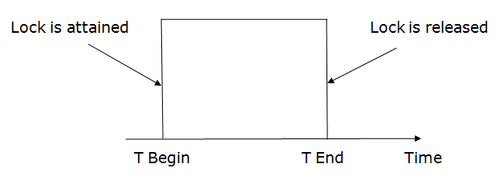

3. Two-phase locking (2PL)
- The two-phase locking protocol divides the execution phase of the transaction into three parts.
- In the first part, when the execution of the transaction starts, it seeks permission for the lock it requires.
- In the second part, the transaction acquires all the locks. The third phase is started as soon as the transaction releases its first lock.
- In the third phase, the transaction cannot demand any new locks. It only releases the acquired locks.
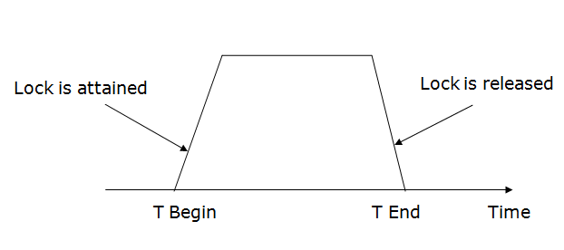

There are two phases of 2PL:
Growing phase: In the growing phase, a new lock on the data item may be acquired by the transaction, but none can be released.
Shrinking phase: In the shrinking phase, existing lock held by the transaction may be released, but no new locks can be acquired.
In the below example, if lock conversion is allowed then the following phase can happen:
- Upgrading of lock (from S(a) to X (a)) is allowed in growing phase.
- Downgrading of lock (from X(a) to S(a)) must be done in shrinking phase.

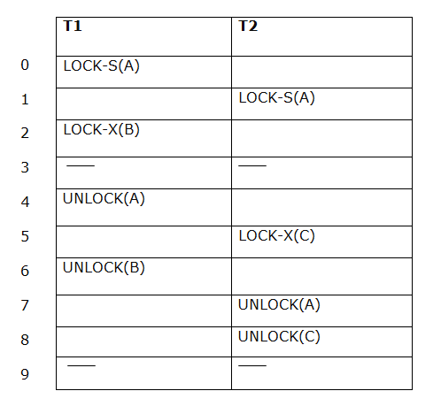

The following way shows how unlocking and locking work with 2-PL.
Transaction T1:
- Growing phase: from step 1-3
- Shrinking phase: from step 5-7
- Lock point: at 3
Transaction T2:
- Growing phase: from step 2-6
- Shrinking phase: from step 8-9
- Lock point: at 6

4. Strict Two-phase locking (Strict-2PL)

- The first phase of Strict-2PL is similar to 2PL. In the first phase, after acquiring all the locks, the transaction continues to execute normally.
- The only difference between 2PL and strict 2PL is that Strict-2PL does not release a lock after using it.
- Strict-2PL waits until the whole transaction to commit, and then it releases all the locks at a time.
- Strict-2PL protocol does not have shrinking phase of lock release.
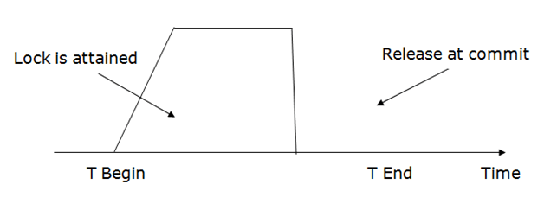

Deadlock in DBMS
A deadlock is a condition where two or more transactions are waiting indefinitely for one another to give up locks. Deadlock is said to be one of the most feared complications in DBMS as no task ever gets finished and is in waiting state forever.
For example: In the student table, transaction T1 holds a lock on some rows and needs to update some rows in the grade table. Simultaneously, transaction T2 holds locks on some rows in the grade table and needs to update the rows in the Student table held by Transaction T1.
Now, the main problem arises. Now Transaction T1 is waiting for T2 to release its lock and similarly, transaction T2 is waiting for T1 to release its lock. All activities come to a halt state and remain at a standstill. It will remain in a standstill until the DBMS detects the deadlock and aborts one of the transactions.

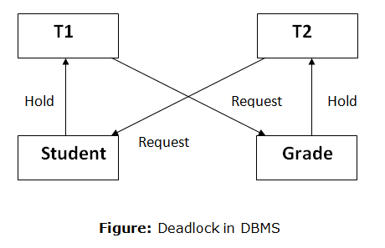

Deadlock Avoidance
- When a database is stuck in a deadlock state, then it is better to avoid the database rather than aborting or restating the database. This is a waste of time and resource.
- Deadlock avoidance mechanism is used to detect any deadlock situation in advance. A method like "wait for graph" is used for detecting the deadlock situation but this method is suitable only for the smaller database. For the larger database, deadlock prevention method can be used.

Deadlock Detection
In a database, when a transaction waits indefinitely to obtain a lock, then the DBMS should detect whether the transaction is involved in a deadlock or not. The lock manager maintains a Wait for the graph to detect the deadlock cycle in the database.

Wait for Graph
- This is the suitable method for deadlock detection. In this method, a graph is created based on the transaction and their lock. If the created graph has a cycle or closed loop, then there is a deadlock.
- The wait for the graph is maintained by the system for every transaction which is waiting for some data held by the others. The system keeps checking the graph if there is any cycle in the graph.
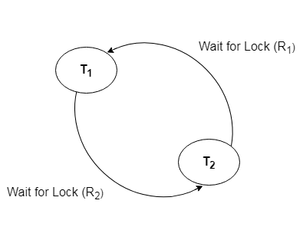

Deadlock Prevention
- Deadlock prevention method is suitable for a large database. If the resources are allocated in such a way that deadlock never occurs, then the deadlock can be prevented.
- The Database management system analyzes the operations of the transaction whether they can create a deadlock situation or not. If they do, then the DBMS never allowed that transaction to be executed.

Wait-Die scheme

In this scheme, if a transaction requests for a resource which is already held with a conflicting lock by another transaction then the DBMS simply checks the timestamp of both transactions. It allows the older transaction to wait until the resource is available for execution.
Let's assume there are two transactions Ti and Tj and let TS(T) is a timestamp of any transaction T. If T2 holds a lock by some other transaction and T1 is requesting for resources held by T2 then the following actions are performed by DBMS:
- Check if TS(Ti) < TS(Tj) - If Ti is the older transaction and Tj has held some resource, then Ti is allowed to wait until the data-item is available for execution. That means if the older transaction is waiting for a resource which is locked by the younger transaction, then the older transaction is allowed to wait for resource until it is available.
- Check if TS(Ti) < TS(Tj) - If Ti is older transaction and has held some resource and if Tj is waiting for it, then Tj is killed and restarted later with the random delay but with the same timestamp.

Wound wait scheme

- In wound wait scheme, if the older transaction requests for a resource which is held by the younger transaction, then older transaction forces younger one to kill the transaction and release the resource. After the minute delay, the younger transaction is restarted but with the same timestamp.
- If the older transaction has held a resource which is requested by the Younger transaction, then the younger transaction is asked to wait until older releases it.

Failure Classification in DBMS
Failure in terms of a database can be defined as its inability to execute the specified transaction or loss of data from the database. A DBMS is vulnerable to several kinds of failures and each of these failures needs to be managed differently. There are many reasons that can cause database failures such as network failure, system crash, natural disasters, carelessness, sabotage(corrupting the data intentionally), software errors, etc.

Failure Classification in DBMS
A failure in DBMS can be classified as:

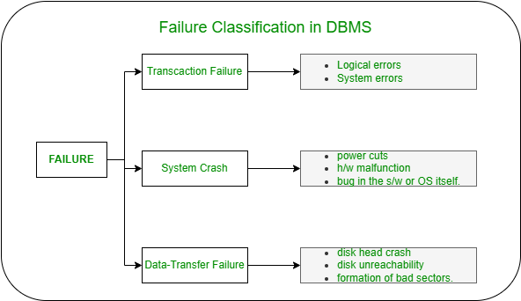

Transaction Failure:

If a transaction is not able to execute or it comes to a point from where the transaction becomes incapable of executing further then it is termed as a failure in a transaction.
Reason for a transaction failure in DBMS:

- Logical error: A logical error occurs if a transaction is unable to execute because of some mistakes in the code or due to the presence of some internal faults.
- System error: Where the termination of an active transaction is done by the database system itself due to some system issue or because the database management system is unable to proceed with the transaction. For example– The system ends an operating transaction if it reaches a deadlock condition or if there is an unavailability of resources.
System Crash:
A system crash usually occurs when there is some sort of hardware or software breakdown. Some other problems which are external to the system and cause the system to abruptly stop or eventually crash include failure of the transaction, operating system errors, power cuts, main memory crash, etc.
These types of failures are often termed soft failures and are responsible for the data losses in the volatile memory. It is assumed that a system crash does not have any effect on the data stored in the non-volatile storage and this is known as the fail-stop assumption.

Data-transfer Failure:
When a disk failure occurs amid data-transfer operation resulting in loss of content from disk storage then such failures are categorized as data-transfer failures. Some other reason for disk failures includes disk head crash, disk unreachability, formation of bad sectors, read-write errors on the disk, etc.
In order to quickly recover from a disk failure caused amid a data-transfer operation, the backup copy of the data stored on other tapes or disks can be used. Thus it’s a good practice to backup your data frequently.
B+ TREES

B + Tree is a variation of the B-tree data structure. In a B + tree, data pointers are stored only at the leaf nodes of the tree. In a B+ tree structure of a leaf node differs from the structure of internal nodes. The leaf nodes have an entry for every value of the search field, along with a data pointer to the record (or to the block that contains this record). The leaf nodes of the B+ tree are linked together to provide ordered access to the search field to the records. Internal nodes of a B+ tree are used to guide the search. Some search field values from the leaf nodes are repeated in the internal nodes of the B+ tree.

Features of B+ Trees

- Balanced: B+ Trees are self-balancing, which means that as data is added or removed from the tree, it automatically adjusts itself to maintain a balanced structure. This ensures that the search time remains relatively constant, regardless of the size of the tree.
- Multi-level: B+ Trees are multi-level data structures, with a root node at the top and one or more levels of internal nodes below it. The leaf nodes at the bottom level contain the actual data.
- Ordered: B+ Trees maintain the order of the keys in the tree, which makes it easy to perform range queries and other operations that require sorted data.
- Fan-out: B+ Trees have a high fan-out, which means that each node can have many child nodes. This reduces the height of the tree and increases the efficiency of searching and indexing operations.
- Cache-friendly: B+ Trees are designed to be cache-friendly, which means that they can take advantage of the caching mechanisms in modern computer architectures to improve performance.
- Disk-oriented: B+ Trees are often used for disk-based storage systems because they are efficient at storing and retrieving data from disk.

Why Use B+ Tree?
- B+ Trees are the best choice for storage systems with sluggish data access because they minimize I/O operations while facilitating efficient disc access.
- B+ Trees are a good choice for database systems and applications needing quick data retrieval because of their balanced structure, which guarantees predictable performance for a variety of activities and facilitates effective range-based queries.

Implementation of B+ Tree
In order, to implement dynamic multilevel indexing, B-tree and B+ tree are generally employed. The drawback of the B-tree used for indexing, however, is that it stores the data pointer (a pointer to the disk file block containing the key value), corresponding to a particular key value, along with that key value in the node of a B-tree.
This technique greatly reduces the number of entries that can be packed into a node of a B-tree, thereby contributing to the increase in the number of levels in the B-tree, hence increasing the search time of a record. B+ tree eliminates the above drawback by storing data pointers only at the leaf nodes of the tree. Thus, the structure of the leaf nodes of a B+ tree is quite different from the structure of the internal nodes of the B tree.
It may be noted here that, since data pointers are present only at the leaf nodes, the leaf nodes must necessarily store all the key values along with their corresponding data pointers to the disk file block, in order to access them.
Moreover, the leaf nodes are linked to providing ordered access to the records. The leaf nodes, therefore form the first level of the index, with the internal nodes forming the other levels of a multilevel index.
Some of the key values of the leaf nodes also appear in the internal nodes, to simply act as a medium to control the searching of a record. From the above discussion, it is apparent that a B+ tree, unlike a B-tree, has two orders, ‘a’ and ‘b’, one for the internal nodes and the other for the external (or leaf) nodes.

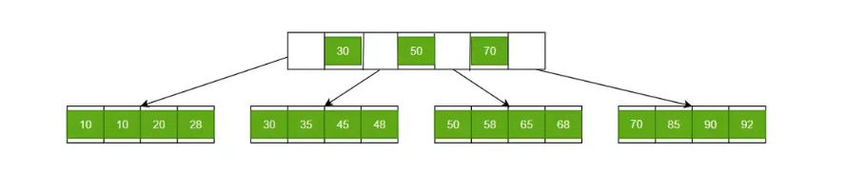
B+ Trees contain two types of nodes:
- Internal Nodes: Internal Nodes are the nodes that are present in at least n/2 record pointers, but not in the root node,
- Leaf Nodes: Leaf Nodes are the nodes that have n pointers.

The B+ trees are extensions of B trees designed to make the insertion, deletion and searching operations more efficient.
The properties of B+ trees are similar to the properties of B trees, except that the B trees can store keys and records in all internal nodes and leaf nodes while B+ trees store records in leaf nodes and keys in internal nodes. One profound property of the B+ tree is that all the leaf nodes are connected to each other in a single linked list format and a data pointer is available to point to the data present in disk file. This helps fetch the records in equal numbers of disk access.
Since the size of main memory is limited, B+ trees act as the data storage for the records that couldn’t be stored in the main memory. For this, the internal nodes are stored in the main memory and the leaf nodes are stored in the secondary memory storage.

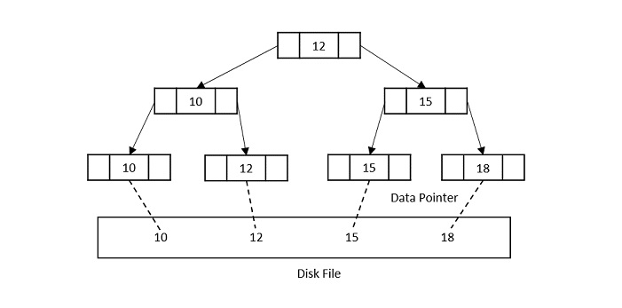

Properties of B+ trees

- Every node in a B+ Tree, except root, will hold a maximum of m children and (m-1) keys, and a minimum of ⌈m2⌉ children and ⌈m−12⌉ keys, since the order of the tree is m.
- The root node must have no less than two children and at least one search key.
- All the paths in a B tree must end at the same level, i.e. the leaf nodes must be at the same level.
- A B+ tree always maintains sorted data.

Hashing in DBMS
In a huge database structure, it is very inefficient to search all the index values and reach the desired data. Hashing technique is used to calculate the direct location of a data record on the disk without using index structure.
In this technique, data is stored at the data blocks whose address is generated by using the hashing function. The memory location where these records are stored is known as data bucket or data blocks.
In this, a hash function can choose any of the column value to generate the address. Most of the time, the hash function uses the primary key to generate the address of the data block. A hash function is a simple mathematical function to any complex mathematical function. We can even consider the primary key itself as the address of the data block. That means each row whose address will be the same as a primary key stored in the data block.
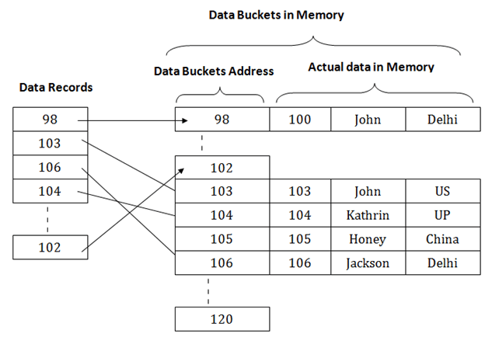
The above diagram shows data block addresses same as primary key value. This hash function can also be a simple mathematical function like exponential, mod, cos, sin, etc. Suppose we have mod (5) hash function to determine the address of the data block. In this case, it applies mod (5) hash function on the primary keys and generates 3, 3, 1, 4 and 2 respectively, and records are stored in those data block addresses.

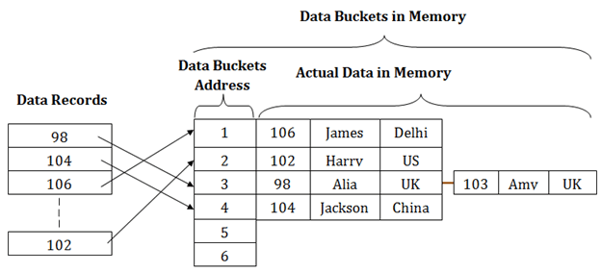

Types of Hashing:
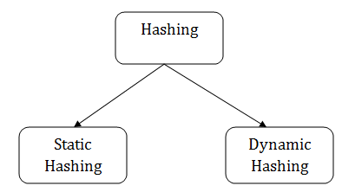

Static Hashing
In static hashing, the resultant data bucket address will always be the same. That means if we generate an address for EMP_ID =103 using the hash function mod (5) then it will always result in same bucket address 3. Here, there will be no change in the bucket address.
Hence in this static hashing, the number of data buckets in memory remains constant throughout. In this example, we will have five data buckets in the memory used to store the data.

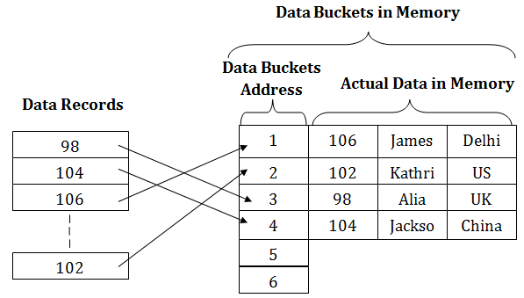

Operations of Static Hashing
- Searching a record
When a record needs to be searched, then the same hash function retrieves the address of the bucket where the data is stored.
- Insert a Record
When a new record is inserted into the table, then we will generate an address for a new record based on the hash key and record is stored in that location.
- Delete a Record
To delete a record, we will first fetch the record which is supposed to be deleted. Then we will delete the records for that address in memory.
- Update a Record
To update a record, we will first search it using a hash function, and then the data record is updated.
If we want to insert some new record into the file but the address of a data bucket generated by the hash function is not empty, or data already exists in that address. This situation in the static hashing is known as bucket overflow. This is a critical situation in this method.
To overcome this situation, there are various methods. Some commonly used methods are as follows:

1. Open Hashing

When a hash function generates an address at which data is already stored, then the next bucket will be allocated to it. This mechanism is called as Linear Probing.
For example: suppose R3 is a new address which needs to be inserted, the hash function generates address as 112 for R3. But the generated address is already full. So the system searches next available data bucket, 113 and assigns R3 to it.

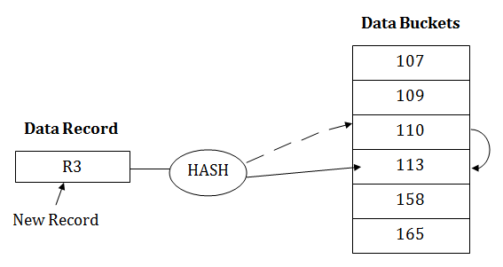
2. Close Hashing
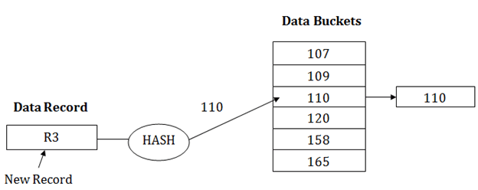
When buckets are full, then a new data bucket is allocated for the same hash result and is linked after the previous one. This mechanism is known as Overflow chaining.
For example: Suppose R3 is a new address which needs to be inserted into the table, the hash function generates address as 110 for it. But this bucket is full to store the new data. In this case, a new bucket is inserted at the end of 110 buckets and is linked to it.

